Project Design Phase
Solution Architecture

Date | 03 October 2026
Team ID | SWTID-2026-8647
Project Name | Implement Client Script & UI Policy (Incident)
Maximum Marks | 4 Marks

Solution Architecture:
For this project, the solution architecture bridges the Incident data-quality problem with ServiceNow configuration-based client-side controls. The architecture is designed to:
- Use the ServiceNow Incident form as the main interaction point for users.
- Apply a UI Policy and UI Policy Actions to dynamically control mandatory, visible, and read-only field behavior.
- Use a basic Client Script configuration to support client-side checking and appropriate user feedback.
- Guide complete Incident information toward a valid Incident record while keeping the configuration simple and maintainable.

Solution Architecture Diagram :

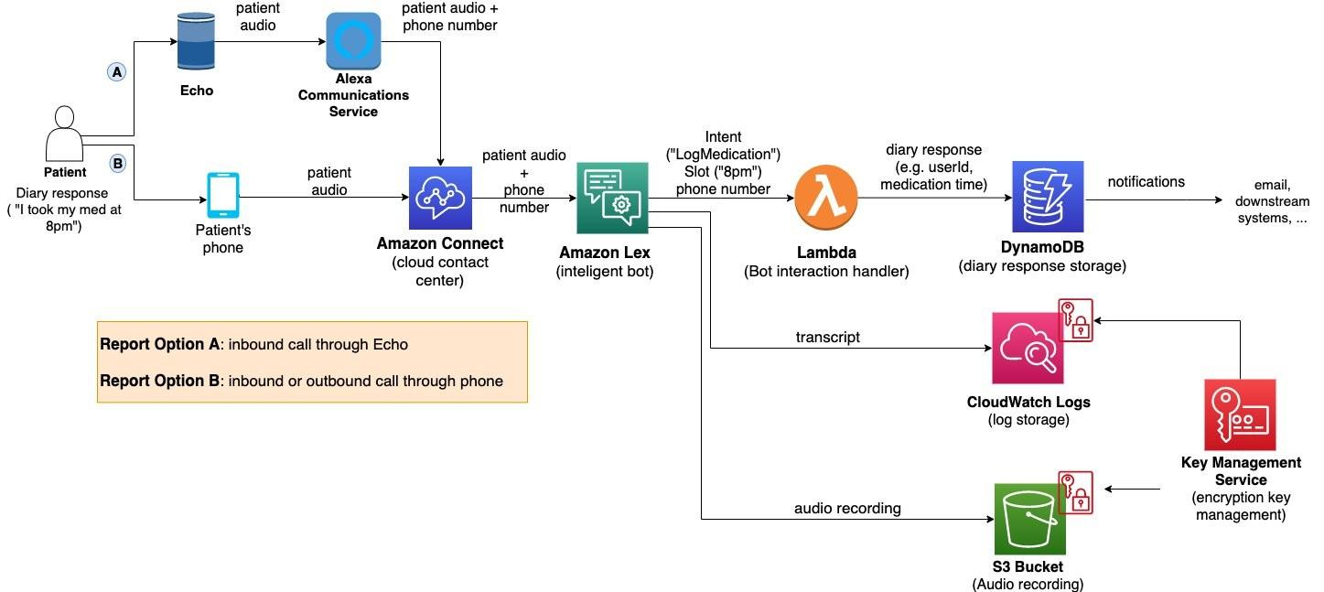
Figure 1: Solution architecture and data flow of the ServiceNow Incident form
Reference: ServiceNow Developer Documentation – UI Policies and Client-side Scripting.

